2. Overall Description
2.1 Product perspective
2.1.1 Scenarios
- Educator creates Tournament:
The technology company CPE (CercoProgrammatoriEccelenti) is currently seeking a group of talented university students to join their company as programmers. Mr. Verdi, the HR manager, know from a friend about a platform called CKB, where enthusiasts can participate in various challenges. Verdi decides to register as an organizer on the platform. After successful registration and account verification, he organizes a programming tournament named "CPE Tournament." Verdi sets the tournament start and end times, battles registration start and end times, the maximum number of battles for join it, and the total achievement to be awarded and internship opportunity.
- Educator creates Battle:
Dr. Rossi, a professor at an engineering school, is usually invited to create various programming exercises. One day, the invitation by CPE, Dr. Rossi creates a competition within the CPE Tournament called "CodingForEver." To meet CPE's recruitment requirements, Dr. Rossi skillfully operates the platform. He selects online compilers such as Java, C, C++, C#, provides the content of the challenge, competition test files, and sets the number of students in a team, the start, and end times of the battle.
- Student participates in Battle:
Alice is a programming enthusiast, usually like to practice in CKB platform and participate in some competitions, receives an invitation to the "CPE Tournament." After reviewing the competition details and rewards, she decides to participate in a battle named "LoneCode." She enters the CKB website through the provided link on her smartphone, logs in with her private account email and password, selects the "LoneCode" battle that she likes and seen the requirements, and clicks "Join." She receives a confirmation email, "Registration Successful." Later, she also notices the "GoCode" competition, which coincides with "LoneCode" but ends later. After careful consideration, she decides to participate in this competition as well.
- Student invites other students to participate in the Battle:
Bob and Calvin, after exploring the "CPE Tournament," decide to participate in a battle named "Trinity." However, while forming a team, they realize that it requires at least three members. Bob thinks of inviting his programming friend David. After getting David's agreement over the phone and obtaining his email, Bob, during team creation, inputs David's email in the invitation field and sends an invitation. David receives the invitation, clicks "Agree to Join," and enters the CKB website through the link to confirm. Bob then receives a "Team Created Successfully" message, and the team successfully registers for the competition.
- Team of students test project:
"ViNCiaMo" is a team of four students. On the day of the battle, they divide the coding tasks among themselves. Vittorio sees the real-time leaderboard, and they are in the second position. This is their last registered battles, but they have one test case left. After a final submission attempt just before the deadline, they pass the test. At the last moment, all team members, Nicola, Carlo, and Monica, see "Pass" on their interfaces. After clicking the "Submit" button, they celebrate excitedly. When the time is up, each team member receives a confirmation email containing details like the number of completed tests, time taken, submission score, and provisional personal ranking.
- Educator evaluates Tournament:
Dr. Rossi receives a notification at 12 PM that the time for the "CPE Tournament" has expired. He logs into the CKB platform using a computer, clicks on the consolidation stage button, selects the top 10 scores, views their profiles, and finds that the student in the second position, Bob, has completed the most battles. Dr. Rossi decides to give him a bonus (the student who completes the most battles can receive an additional bonus). After a second check, the platform reassigns rankings. Dr. Rossi reviews it and selects "Close Consolidation Stage." After confirming again, the platform sends the final ranking information to all participants via email.
- Student receives results:
Vittorio, during dinner, receives a "CPE Tournament final rank" message. Upon opening it and logging in, he sees that his ranking, which was first at submission, has dropped to the second position. Confused, he notices a button below the email saying, "Contact with Educator." The platform provides him with Dr. Rossi's email. After understanding the situation, Vittorio clicks "Confirm Result" (the platform automatically selects it if not clicked during the publication phase).
- Educator closes Battle and Students receive rewards:
After the Publication Stage, Dr. Rossi logs into the CKB platform, clicks "Close Tournament," and after confirming, the platform notifies all participating students and educators that the competition is officially over. At this point, the platform automatically distributes rewards to students who meet the ranking requirements and updates their individual competition information, titles, etc.
- Student can practice on the platform (additional function):
Kevin, preparing for a programming exam, knows from his classmate Alice that the CKB platform has many past competition problems for good practicing programming skills. Kevin decides to register on the platform and, under the "Practice on Yourself" section, sees various competition problems and effective answers published by educators. Kevin clicks on the "CPE Tournament " and "LoneCode" battle, attempting to write and submit his code to the platform. After the platform accepts Kevin's submission in a text file format, it compiles it online, and the interface displays the compilation result.

2.1.2 Domain class diagram

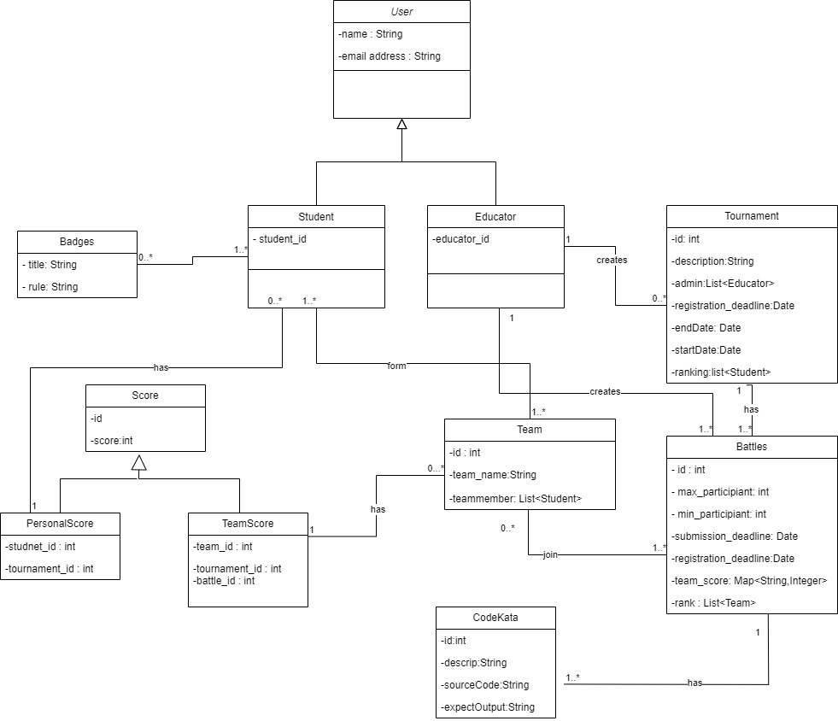

2.1.3 State Diagram
Tournament Process
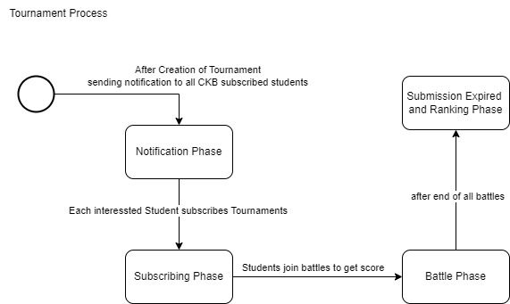
This state diagram illustrates how a Tournament in CKB can progress through different phases, reflecting the lifecycle of a tournament from subscription to battle execution, rating, and notification. The actual states and transitions may involve additional complexities based on the detailed behaviour of the CKB platform.

Battle Process
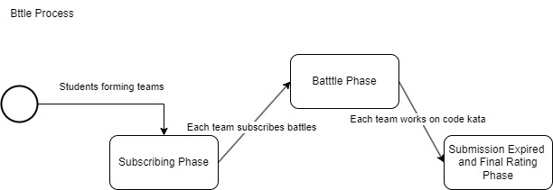
This state diagram captures the progression of a battle process in CKB, reflecting the phases of Subscribing, Team Formation, Battle Execution, and Rating & Ranking. The actual states and transitions may involve additional details based on the specific behavior of the CKB platform.

2.2 Product Functions
2.2.1 Students Functionalities
Authentication and Profile Management:
Additionally, providing access to personal profiles enhances user engagement and facilitates a sense of identity within the community. The invitation functionality promotes interaction among students, encouraging them to collaborate and participate in competitions together. The system generates notifications to keep users informed about the success or failure of their actions, ensuring transparency and a smooth user experience.
- User Registration and Login:
  - Description: Provide students with the capability to create user accounts through registration and access their accounts through login credentials.
  - Functionality:
    - Allow students to register by providing necessary information.
    - Validate registration information for accuracy and completeness.
    - Notify students of successful or failed registration.
    - Enable students to log in using their registered credentials.
    - Send notifications for successful or failed logins.
- Personal Profile Viewing:
  - Description: Allow students to access and view their personal profiles, providing them with an overview of their account details and activity.
  - Functionality:
    - Enable students to navigate to their profile section.
    - Display relevant information such as username, email, and participation history.
    - Facilitate a personalProfile interface for easy navigation.
- Invitation Functionality:
  - Description: Empower students to invite their peers to participate in battles, fostering a sense of community and collaboration.
  - Functionality:
    - Allow students to send invitations to specific battles.
    - Implement constraints to manage the number of invitations according to the number of participants.
    - Provide notifications to invitees with details of the invitation.
Battle Participation Features:
The battle participation features aim to enhance the overall engagement of students on the platform. By offering choices in programming languages, facilitating seamless tournament and battle subscriptions, and providing access to GitHub repositories, students can actively participate in coding challenges. Real-time score viewing, notifications, and rankings add a competitive and interactive dimension to their experience. The ability to explore past battles and engage in post-battle activities, such as practice mode and code testing, contributes to continuous learning and skill development.
- Programming Language Selection:
  - Description: Provide students with the flexibility to choose their preferred programming language for training.
  - Functionality:
    - Offer a programming-language interface where students can select their desired programming language.
    - Ensure a diverse range of languages to cater to individual preferences and learning goals.
- Tournaments Subscription:
  - Description: This feature enables students to participate in tournaments by subscribing to them.
  - Functionality:
    - Allow students to explore and view details of individual tournaments available on the platform.
    - Provide a straightforward subscription process for students to sign up for their chosen tournaments.
    - Ensure a tournaments interface for easy navigation through the list of available tournaments.
- Battles Subscription:
  - Description: This functionality allows students to subscribe to specific battles within the tournaments they have already joined.
  - Functionality:
    - Provide an option for students to explore and select specific battles within the tournaments they are interested in.
    - Facilitate a distinct subscription process for battles, ensuring clarity in the battle selection and enrollment process.
    - Ensure seamless navigation to find and subscribe to battles within the chosen tournament.
- GitHub Repository Access:
  - Description: Facilitate students' access to the GitHub repository relevant to their participating battle.
  - Functionality:
    - Platform sends students a GitHub link associated with their selected battle.
    - Students utilize the provided link to upload their battle-related code, ensuring a seamless integration between the platform and GitHub for repository management.
- Score Viewing and Notifications:
  - Description: Provide students with real-time access to their competition scores and notifications for relevant events.
  - Functionality:
    - Display a dedicated section for students to view their scores obtained in battles.
    - Implement a notification system to alert students about various events such as new tournaments, battle updates, or score announcements.
- Rankings Exploration:
  - Description: Enable students to explore and view rankings within both individual battles and overall tournaments.
  - Functionality:
    - Provide a rankViewing interface for students to access battle rankings.
    - Differentiate between rankings within specific battles and broader tournament rankings.
- Past Battles Overview:
  - Description: Allow students to revisit and review details of past battles they participated in.
  - Functionality:
    - Provide a comprehensive list of past battles in which the student has taken part.
    - Include details such as battle names, dates, and performance summaries.
- Practice Mode Selection:
  - Description: Enable students to opt for a practice mode after completing a battle.
  - Functionality:
    - Allow students to choose the practice mode for ongoing learning and skill enhancement.
    - Provide a practice interface for uploading and testing code within the practice mode.
    - Display practice rankings to highlight individual performance in a non-competitive environment.
2.2.2 Educators/Platform Functionalities
Educator Registration and Management Features:
The Educator Registration and Management features involve the processes related to the registration and login of educators. Educators have dedicated registration and login functionalities tailored to their roles.
Educator Registration and Login:
- Description: Provide educators with the ability to register and log in to the CodeKataBattle platform.
- Functionality:
    - Implement a dedicated and secure registration process for educators, allowing them to create accounts with relevant information.
    - Develop an educatorLogin interface that enables educators to access their accounts with proper authentication.
    - Ensure that the registration and login interfaces meet the specific needs of educators, emphasizing security and ease of use.
Tournament and Battle Management Features:
The Tournament and Battle Management features cater to the needs of educators, providing them with tools to organize and oversee coding tournaments and battles. The creation of tournaments is a fundamental aspect, allowing educators to set the stage for engaging coding challenges. The inclusion of permission management ensures collaborative tournament creation, where multiple educators can contribute. The creation of battles within tournaments is enriched with various configuration options, from uploading code kata to defining participant limits and deadlines. Grading parameter configuration, including security percentages, adds a layer of customization to meet the specific requirements of each battle. These features collectively contribute to a robust and flexible system for educators to curate coding challenges tailored to their educational goals.
- Tournament Creation and Permissions:
  - Description: Empower educators to create tournaments and manage permissions for battle creation.
  - Functionality:
    - Provide a tournament interface for educators to create new tournaments on the platform.
    - Implement a permission system allowing educators to grant specific individuals the authority to create battles within a tournament.
    - Include options for setting titles and rules for tournaments, referred to as "tournament badges."
- Battle Creation and Configuration:
  - Description: Facilitate educators in creating battles with diverse configuration options.
  - Functionality:
    - Enable educators to upload code kata with corresponding answers (answers revealed after the competition).
    - Allow educators to set participant limits for each battle to manage the number of participants.
    - Provide options to set registration deadlines, ensuring timely and organized battle sign-ups.
    - Implement submission deadlines to define the period during which participants can submit their solutions.
    - Allow educators to configure grading parameters, including security percentages, to customize the evaluation process.
Notification and Communication Features:
The Notification and Communication features are integral to keeping students informed and engaged during their participation in tournaments and battles on the CodeKataBattle platform. These features contribute to a seamless user experience by providing timely updates on events, GitHub repository links, and battle outcomes. Furthermore, the system allows insight into user preferences and actions through notifications related to specific choices, such as opting for practice mode.
- Tournament Creation Notification:
  - Description: Notify students about the creation of a new tournament on the platform.
  - Functionality:
    - Automatically send notifications to all registered students upon the creation of a new tournament.
    - Include essential details such as the tournament name, start date, and relevant information.
    - Ensure timely delivery of notifications to maximize student awareness.
- Upcoming Battles Notification:
  - Description: Keep students informed about upcoming battles.
  - Functionality:
    - Automatically send notifications to students in advance of upcoming battles.
    - Include details such as battle names, dates, and other relevant information.
    - Allow students to plan their participation and preparation accordingly.
- GitHub Repository Link Notification:
  - Description: Notify students of the GitHub repository link associated with a battle after the registration deadline.
  - Functionality:
    - Send notifications to registered participants with the GitHub repository link.
    - Ensure students have access to the repository for code submission and collaboration.
    - Include clear instructions on utilizing the GitHub repository for the battle.
- Tournament/Competition End Notification:
  - Description: Inform students about the conclusion of a tournament or individual battle.
  - Functionality:
    - Automatically send notifications to all participants when a tournament or battle ends.
    - Include details such as final scores, rankings, and any post-battle activities.
    - Provide a summary of the battle and acknowledge participant efforts.
Evaluation and Scoring Features:
The Evaluation and Scoring features are designed to ensure a comprehensive and fair assessment of student code on the CodeKataBattle platform. The automatic code evaluation functionality leverages GitHub commits and practice mode submissions to provide timely and objective feedback. This includes the extraction, analysis, testing, and calculation of scores based on various criteria. Educators are granted access to view student code in GitHub repositories, allowing for a deeper understanding of the submitted work.
For scenarios where manual evaluation is required, educators have the flexibility to assess code after the submission deadline. This manual evaluation involves in-depth analysis, testing, and the application of personalized criteria to determine scores. The combination of automatic and manual evaluation ensures a thorough assessment process that considers both objective and subjective aspects of student performance. Overall, these features contribute to a robust evaluation and scoring system within the CodeKataBattle platform.
- Automatic Code Evaluation:
- GitHub Commits and Practice Mode Evaluation:
  - Description: Automatically assess student code submitted through GitHub commits or during practice mode.
  - Functionality:
    - Implement a system to extract the latest code from student GitHub repositories.
    - Analyze and test the code against predefined criteria, such as code kata.
    - Calculate scores based on functional aspects, timeliness, and quality levels.
    - Record and upload/update the automatically generated scores to the platform.
- Educator Code Viewing:
  - Description: Allow educators to view student code in GitHub repositories for comprehensive evaluation.
  - Functionality:
    - Provide educators with access to the code submitted by students through GitHub commits.
    - Facilitate a codeViewing interface for educators to navigate and review the code.
    - Ensure secure and controlled access to maintain the integrity of the evaluation process.
- Manual Code Evaluation by Educators:
Manual Code Evaluation After Submission Deadline:
  - Description: Enable educators to manually evaluate student code after the submission deadline.
  - Functionality:
    - Allow educators to analyze and test the submitted code manually.
    - Calculate scores based on a personalized assessment, considering factors beyond automated evaluations.
    - Provide educators with the ability to enter and send manual scores to the platform.
Result and Ranking Management Features:
The Result and Ranking Management features are designed to streamline the post-battle processes on the CodeKataBattle platform. After each battle, the platform undertakes actions to record scores, update tournament standings, and maintain individual student profiles with relevant statistics. The announcement and updating of scores contribute to transparency and recognition for participants.
Educators have the capability to access and view rankings within both battles and tournaments, allowing them to gauge student performance and identify areas for improvement. The combination of these features creates a dynamic and engaging environment for both students and educators, fostering healthy battle and continuous learning within the CodeKataBattle platform.
- Post-Battle Actions:
  - Description: Enable the platform to perform various actions after each battle concludes.
  - Functionality:
    - Record and store battle scores, ensuring an accurate and comprehensive database.
    - Add or update tournament scores based on the results of individual battles.
    - Record the number of code uploads by students and update the counts in their individual profiles.
    - Announce and update battle and tournament scores on the platform.
    - Send battle ranking notifications to participating students, providing them with feedback and recognition.
    - Upload solutions for practice mode to enhance the learning experience.
- Educator Access to Rankings:
  - Description: Allow educators to access and view rankings within both individual battles and overall tournaments.
  - Functionality:
    - Provide educators with a rankViewing interface to explore rankings within specific battles.
    - Facilitate easy navigation to view rankings within broader tournament categories.
    - Display detailed information, including participant names, scores, and any additional relevant data.
    - Ensure secure and controlled access to ranking information.
Tournament Closure and Badge Awarding Features:
The Tournament Closure and Badge Awarding features are crucial components of the CodeKataBattle platform, offering educators control over tournament closure and providing students with recognition through badges.
Educators can initiate the closure of a tournament, ensuring that this action is intentional and well-regulated. After each tournament, a series of post-tournament actions are executed. Students receive notifications regarding the closure of the tournament, and the platform checks if they meet the badge requirements. If criteria are met, badges are uploaded or updated on individual student profiles, acknowledging their achievements.
These features contribute to the efficient and organized management of tournaments, providing closure when necessary and recognizing students for their accomplishments through the awarding of badges.
- Tournament Closure:
  - Description: Empower educators to officially close a tournament on the CodeKataBattle platform.
  - Functionality:
    - Provide educators with the authority to close a tournament through a dedicated interface.
    - Ensure that closure is a controlled and deliberate action, preventing accidental closures.
    - Include necessary checks and confirmations to verify the intent of the closure.
- Post-Tournament Notifications and Badge Awarding:
  - Description: Implement actions to be performed after each tournament concludes.
  - Functionality:
    - Notify students of the closure of the tournament, providing them with relevant information.
    - Conduct checks to determine if students meet the current tournament's badge requirements.
    - Upload or update badges to individual student profiles based on the badge criteria.
    - Ensure that badge awarding is accurate and aligned with the achievements of participating students.
2.3 User Characteristics
The CKB platform caters to two main user roles: students and educators. Each user's experience is tailored to their respective needs and objectives within the platform.
2.3.1 Students
Students engage with the platform to enhance their coding skills through code kata battles. Their experience revolves around participation in challenges, collaborating with peers, and submitting solutions within specified deadlines. Students also have the opportunity to view and showcase earned badges on their profiles, reflecting their achievements and participation in various tournaments.
2.3.2 Educators
Educators play a crucial role in creating and overseeing the learning environment on the CKB platform. They have the responsibility to design and upload code katas, set parameters for battles, and establish deadlines. Educators can also grant permissions to colleagues to create battles within a specific tournament. The platform empowers educators to assess student performance, assign scores, and define badges and rules to recognize and reward achievements. Additionally, educators have access to tools that allow them to track student’s progress and overall engagement with the platform.
2.4 Assumptions, Dependencies and Constraints
Domain Assumptions
Identifier | Description
D1 | The CKB platform assumes that users have a stable internet connection to access and interact with its features.
D2 | Once the registration deadline for tournaments or battles has passed, students cannot register for any ongoing or upcoming events.
D3 | After the deadline of a tournament, no new battles can be created within the scope of that tournament.
D4 | The system must ensure a necessary timestamp between the end of the last battle of a tournament and the conclusion of that tournament.
D5 | Users must undergo a secure authentication phase during the login process to access the CKB platform.
D6 | CKB relies on access to GitHub functionality for its features to operate effectively.
D7 | Educators can only rate student submissions after the submission deadline has passed.
D8 | The platform is expected to deliver notifications to users within a time frame of one minute.
D9 | The overall tournament score is the sum of scores from all individual battles within that tournament.
D10 | Each badge earned by a student is associated with a specific tournament, reflecting the achievements within that context.
D11 | Students must respect to the specified maximum and minimum number of group members when forming teams for battles.
D12 | Each student is expected to participate in a single team for a specific battle, promoting fairness and avoiding potential conflicts of interest.

These assumptions, dependencies, and constraints provide a foundation for the functioning of the CKB platform and guide the development and user interaction processes.

